Networking event 2024: Coachella Generale

Theme:

Music

SG

Date: 11 december

Activities:

* Photo booth with props on musical theme
* Video, 1mn Taylor swift 1min speech
* Mid session interactive quiz about music:
  + Selected few will partipate in a tournament with some senior management (2 women, 2 man)
  + Online for others
* Posters about woman in musical history

Organization:

* Invitation to be sent via **happening**: 125 spots
* Marketing emails:
  + 26 November
  + 29 November
  + 6 December
* Photobooth:
  + Animator required
  + Printer
* Pre-printed named tags:
  + Color coded prior
  + Golden ticket in it
  + QR code behind to add contact: <https://qrexplore.com/generate/> (bulk generation (more details [here](https://en.wikipedia.org/wiki/MeCard_(QR_code)#:~:text=MeCard%20is%20based%20in%20UTF,size%20limitation%20of%20QR%20Codes.))
* Pre-printed registration qr code
* Pre-printed quiz qr code
* Structure
  + Kick off
    - Introduction
    - Networking rules
    - Separator
  + Phase 1
  + Mid-session break
  + Speech from AWN ?
  + Phase 2
  + Phase 3

Presentation ideas

* Coachella
* Name idea from Chat gpt
* Sun vibes
* California
* Music
* Line up program
* Stage map for agenda?

**Quiz (9 questions)**

1. **Music group**

Q: As of today, who is considered to be **the most successful American group on the US** Billboard Hot 100 with 12 number-one peaks.

A: The supremes - holding the record since 1970. The closest group after them is Hall & Oates with 6.

List: The beatles, destiny’s chile, the supremes, the Jackson 5

1. **Billboard n01 first**

Q:

A: Connie Francis broke the No. 1 gender barrier on the Hot 100 in 1960 with “Everybody's Somebody's Fool”.

List:

1. **Representation (**https://assets.uscannenberg.org/docs/aii-inclusion-recording-studio-20240130.pdf)

Notes: In 2023, 35% of artists on the Billboard Hot 100 Year-End Chart were women, a 12-year high. This is an increase from 2021, when 23.3% of artists were women, and from 2012, when the percentage was lower. However, women still make up less than a quarter of artist roles across all 12 years examined.

In 2022: 30%

Producers: Women remain underrepresented as producers, with only 6% of producers of top-charting songs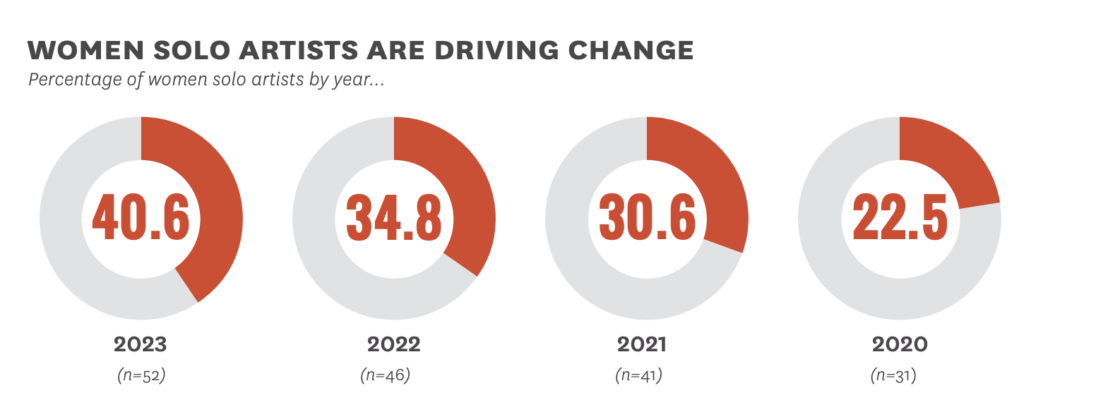

1. **Top100 occurrence breakage (https://www.billboard.com/pro/taylor-swift-most-hot-100-hits-among-women/)**

Taylor Swift breaks the record for the most Billboard Hot 100 entries among women in the chart's 62-year history. Now with 113, as of the chart dated Aug. 8, she passes Nicki Minaj, with 110.

Most Hot 100 Entries Among Women  
113, Taylor Swift  
110, Nicki Minaj  
73, Aretha Franklin  
65, Beyoncé  
62, Rihanna  
57, Madonna  
56, Dionne Warwick  
53, Connie Francis  
52, Ariana Grande  
49, Miley Cyrus  
48, Mariah Carey  
48, Brenda Lee  
41, Mary J. Blige  
41, Janet Jackson  
41, Barbra Streisand

1. **Most grammy’s won:**

Beyoncé is the most Grammy Award winning artist of all times with 32 trophies to her name.

1. **Billionaire’s club**

Taylor swift (1.6B), Rihanna (1.3B), Selena Gomez (1.3B)

1. **Who was the first woman inducted into the Rock & Roll Hall of Fame?**

A: Aretha Franklin

List: Aretha Franklin, Tina Turner, Zola Taylor, Bessie Smith

Note: The Hall inducted no women in its first year.

1. **% of woman inducted in the Rock’n’roll all of fame**

A:Barely 8% of its inductees are female

Note: Artists become eligible 25 years after releasing their first record.)

1. **Who is the most followed women musician on Instagram?**

A: Selena Gomez (behind Cristiano Ronaldo (644M) and Leo Messi (504M))

List: Selena Gomez (423M), Ariana Grande(376M), Beyonce (314M), Taylor Swift (283M)